To check how many times a word occur in file is by command :=
$ grep -c <string > <file path>

If we want to use case in-sensitive :=
$ grep -ci <string> <file path>

If we want to match some file in directory
$ grep -l <filename>*

To see fancy name in terminal use “$ figlet <string>”

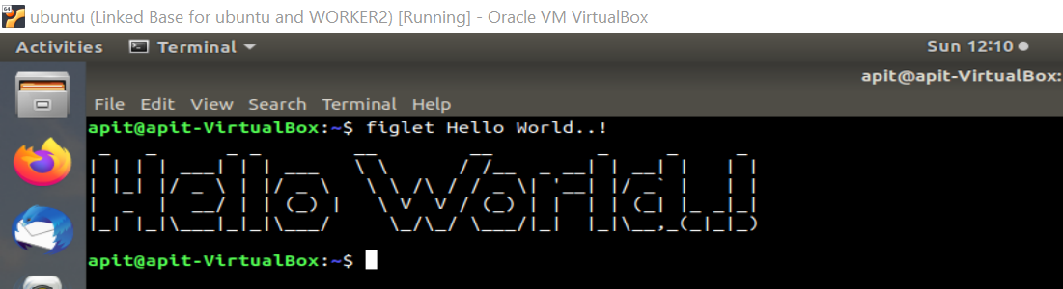

Archive is not a compress file is the same files coupled in a single pakage. It does not reduce any file size.

$ tar -cvf <filename1> <filename2> ….. => this is used to create archive .
c => create
v => verbose
f => to specify file name

Here zip is used to compress file.
$ tar -cvzf <filename1> <filename2> ……. here z=> is used to gun zip. And extension of gun zip is “gz”
Here we will discuss 3 zip method :-

gzip => gun zip
bzip => bun zip
zip

All above three method used to zip file , but there algorithm and there extension are different.

$ du -sh <path/to/dir> => this will be used to see size of directory.

Also in Archive we can update our archive file if any one of the file is update .
suppose we have 10 file in a archive and we have edited a file6 so we can also use

$ tar -uvf archive file *.file => this will update file 6 , automatically.

Here u => this will update our archive with new update.
This is beauty of archive.

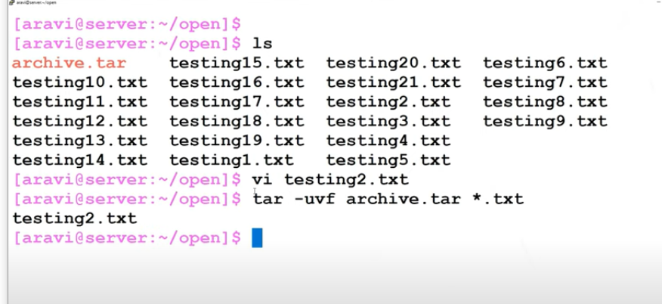

To list out all the file in archive :-
$ tar -tf <archive.tar>

To extract all the file from archive file :-
$ tar -xvf <archive.tar>

x => this is to expand that file.

To compress a file :-

$ tar -cvzf compress.tar.gz *.txt => this will create a gun zip compressed file.

$ du -sh compress.tar.gz => this will show reduce size of compress file.

To extract :-
$ tar -xzvf <.tar.gz file>

Also for bun zip use :-

$ tar -cvjf compress.tar.bz2 *.txt => this will create a bun zip compressed file.

j => for bun zip
.bz2 => this is the extension for bun zip.

To extract :-
$ tar -xjvf <.tar.bz2 file>

If we want high compression ratio we can use $ zip command
$ zip -9 -r <final zip name .zip > <path /to/zip>

And if we want to exclude some file (option -x ) on zip target we can use
$ zip -9 -r test1.zip -x /home/arpit -x /home/arpit/example.tar.gz

Here example.tar.gz will be exclude from zip compression.

If you want to delete some file from zip file then we can also do that using “option -d”

$ zip -d test1.zip <delete file name>

To update content use option “-fr”

To unzip the zip file use “$ unzip” command like
$ unzip <zip file name>

VIM command

x - to delete a character .
. - for redo
0 - for home position
$ - move to end of the line

gg - for beginning of line
G - for end of line

gg = G => indentation of all line from beginning to end

gg d G => delete all lines from beg to end .

/string name => to search the string
n => search string from top to bottom
N => search string from button to top

Shift + G => go to last line of the file
Shift + h => go to first line of the screen
Shift + z => save & quit

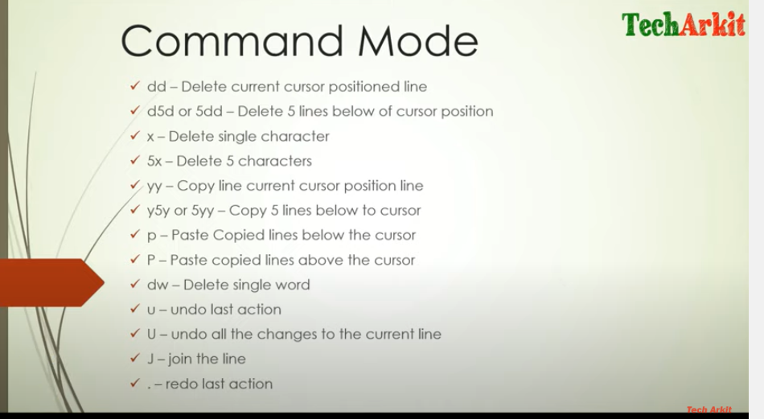

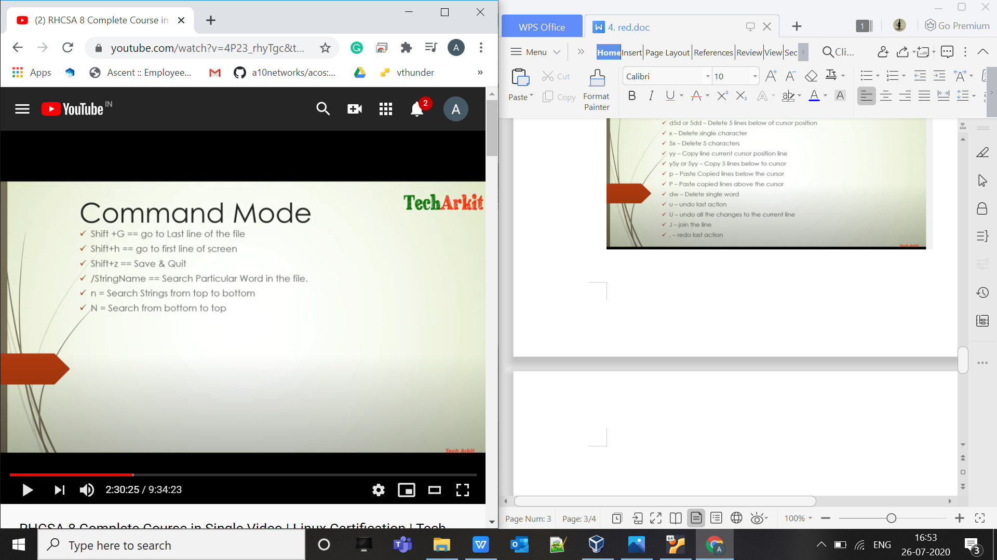

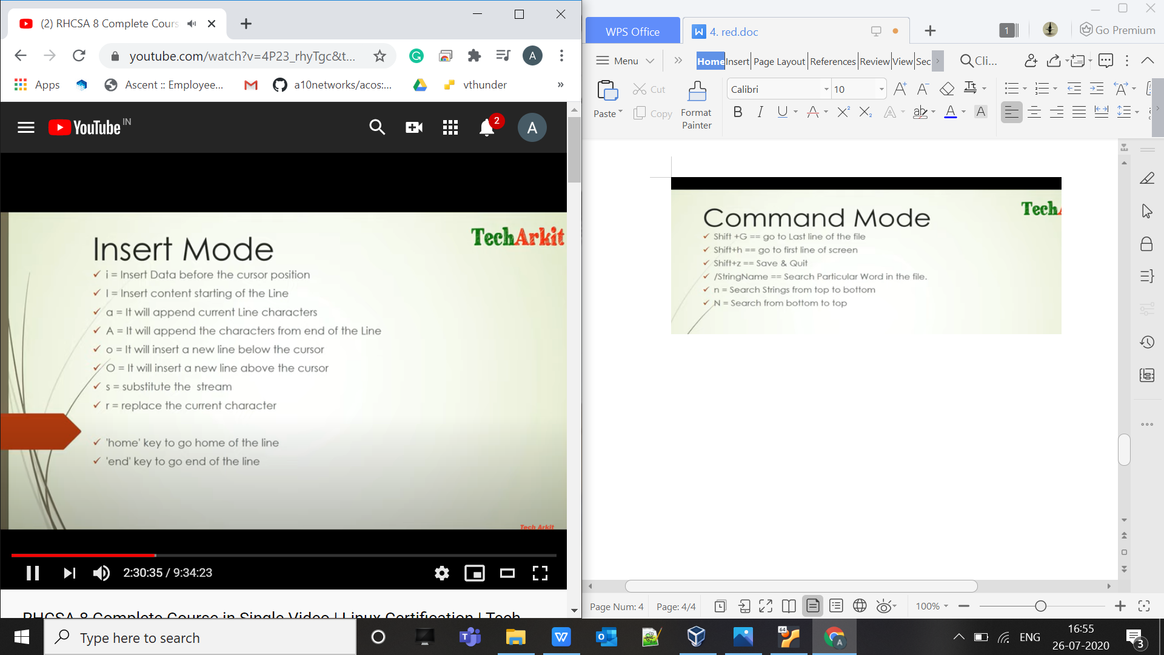

:q => quit
:q! => quit forcefully
:wq! => save and quit forcefully

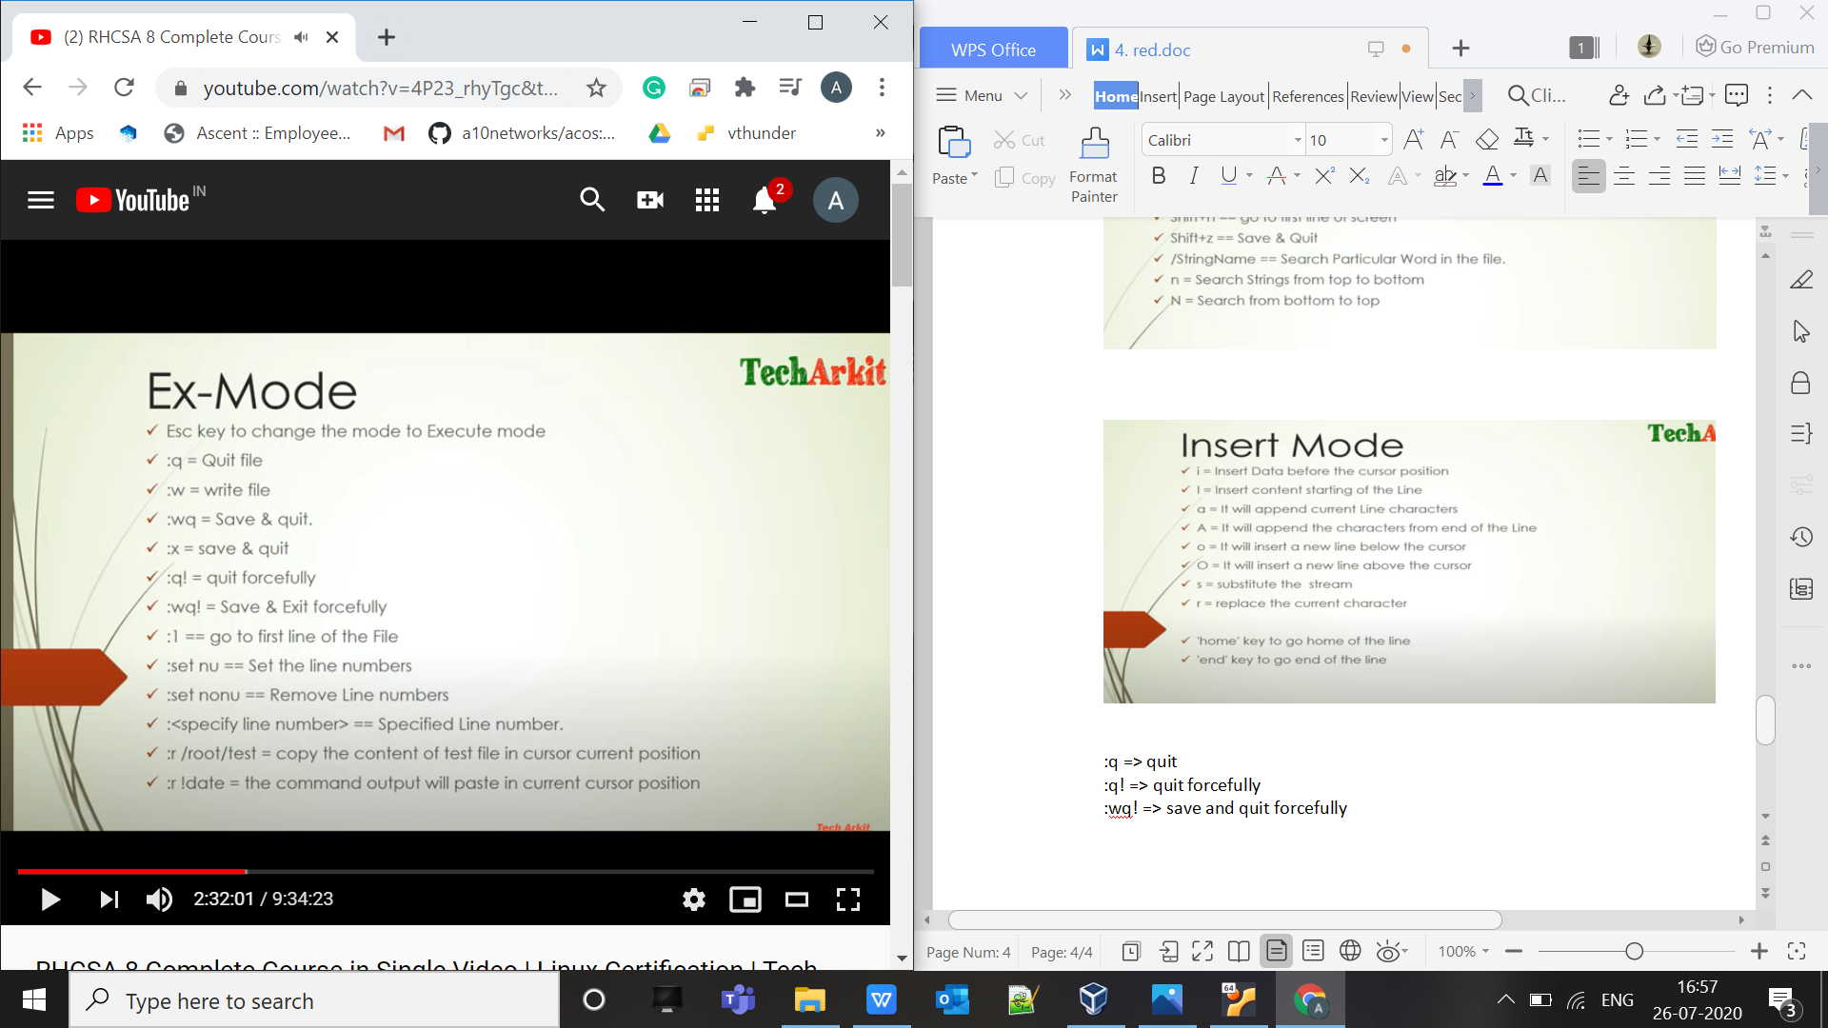

:syntax on => to see the fancy colour in code.

:r /root/test => copy the content for file

In putty just use “Ctrl+a + Esc ” and do up and down the putty screen .

To print current date

:r !date => this will print date on the current cursor location .

:set paste + I => to paste without losing data
:set nopaste =>

Vim => Vi iMproved version

To replace word /string in vim

If you want to replace one by one use
:%s/old_string/new_string => then follow other command as we have on the screen as y y

:%s/old_string/new_string/g

Here last g means global character changes .

